[ITI41120 Applied Computer Science Project](https://www.hiof.no/english/studies/courses/iio/itk/2023/spring/iti41120.html)

**Topic**: Algorithm for Energy Management on an Electric vehicle

**Research areas involved:** Cyber-physical systems, Machine Learning

**Skills needed:** Experience with MATLAB/Simulink, basics of reinforcement learning

**Contact:** Maben Rabi ([maben.rabi@hiof.no](mailto:maben.rabi@hiof.no)),

**Special requirements**: This project is intended to result in a submission to a competition:

https://github.com/DLR-VSDC/IEEE-MVC-2023

This means that we need to:

* Register for the competition around the 20th of December
* Submit the algorithm around the 20th of March

This means that the period between mid-December and the end of March shall be very very hectic. The project shall be executed in a hybrid style: partly under the Agile (panic ;-)) model of development, and partly in the waterfall (Zen level composure ;-)) model of development. Between **two to four students could work** on this project.

**Content:** The purpose of this project is to come up with an algorithm that does two things: (i) based on the 3-dimensional map of the planned route, decide on the instantaneous speed to be taken, and (ii) decide how much of the instantaneous power should be delivered from using the fuel and how much should come from stored energy in the battery (or whether excess energy should be produced, to be stored in the battery). The performance of the algorithm shall be judged by a set of metrics such as for example: total energy expenditure for trip, battery degradation over trip etc.

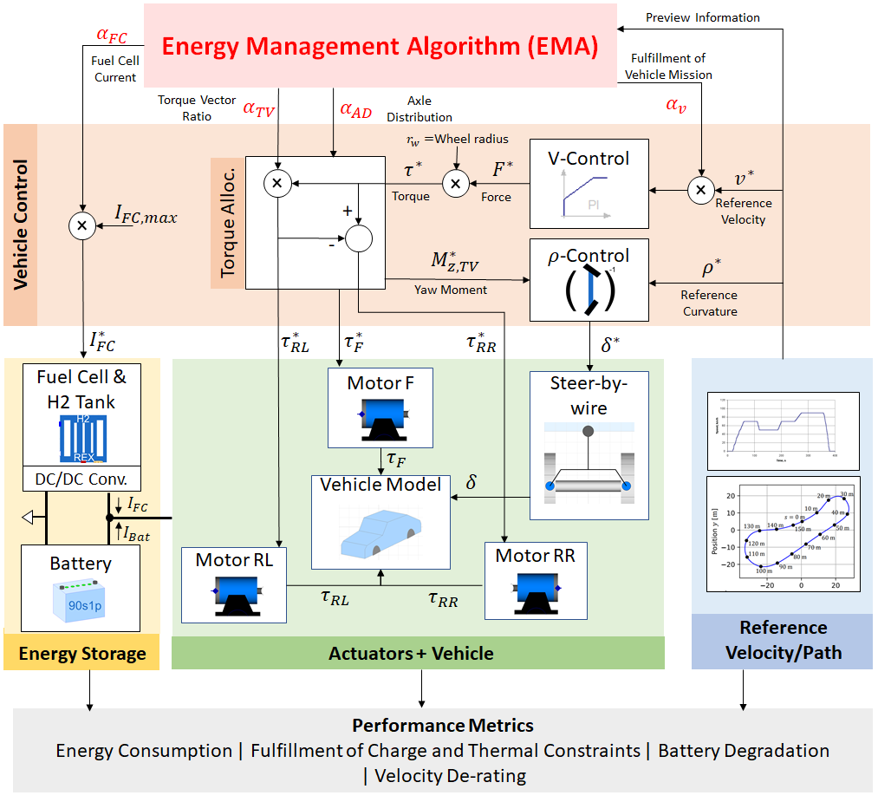

Figure : Image source: IEEE-MVC-2023